Data Understanding:
- Describe the dataset: Include the structure (rows, columns, data types) and its contents.
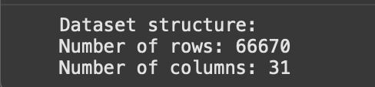
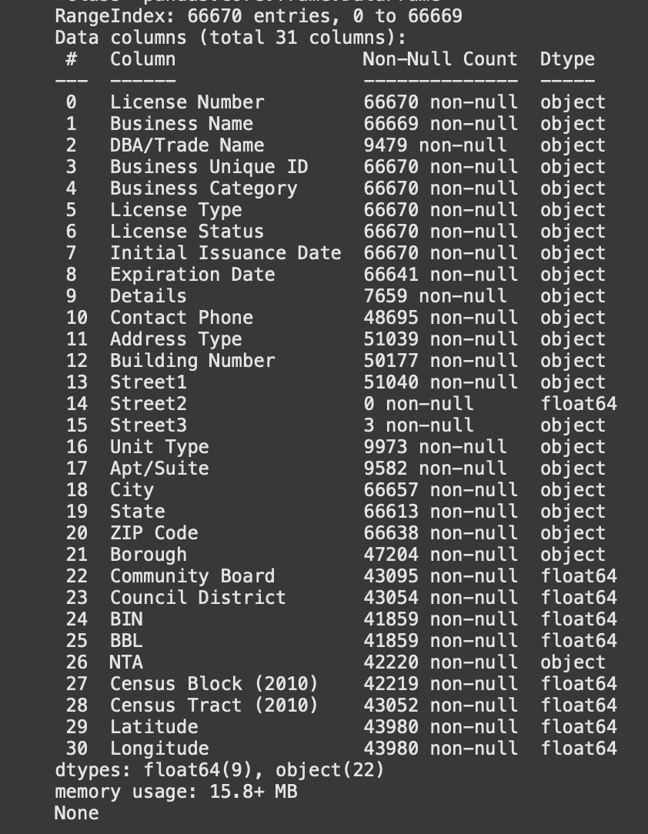
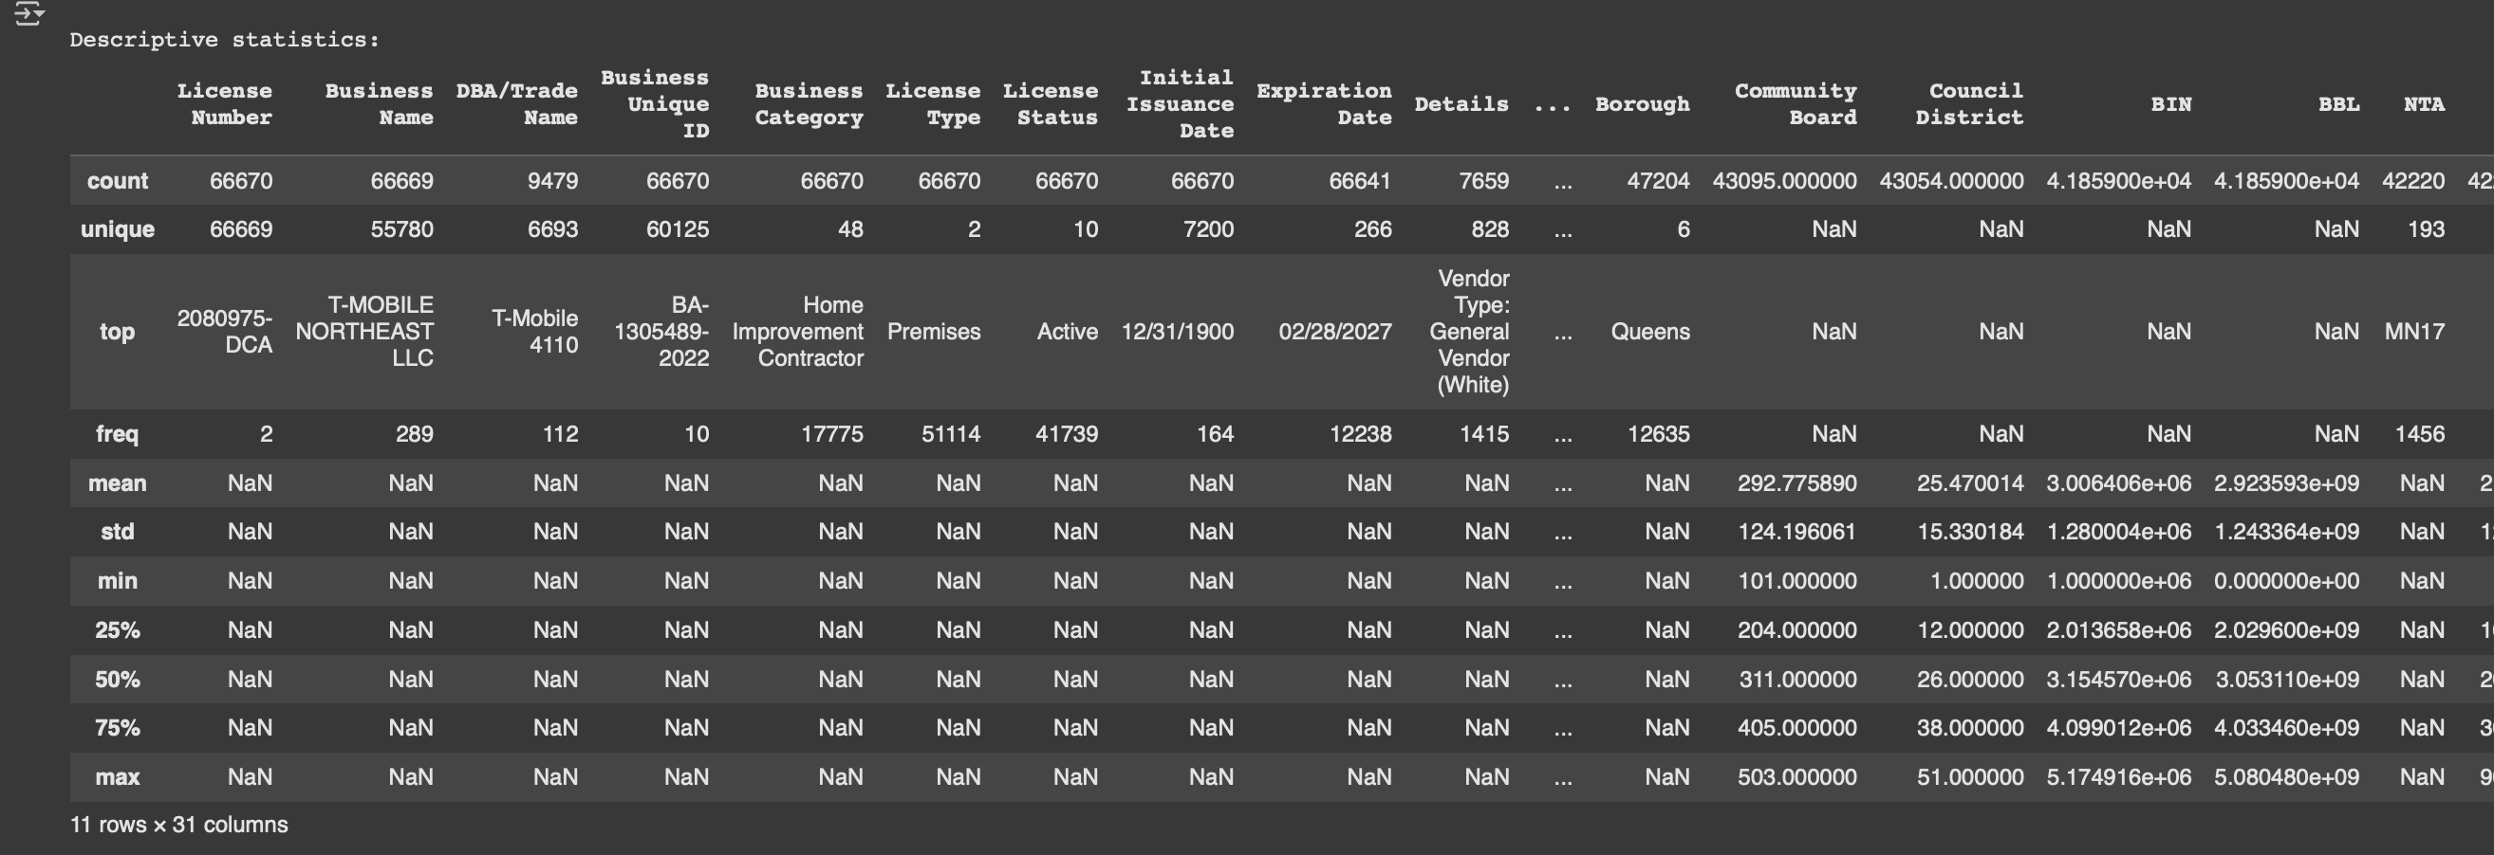
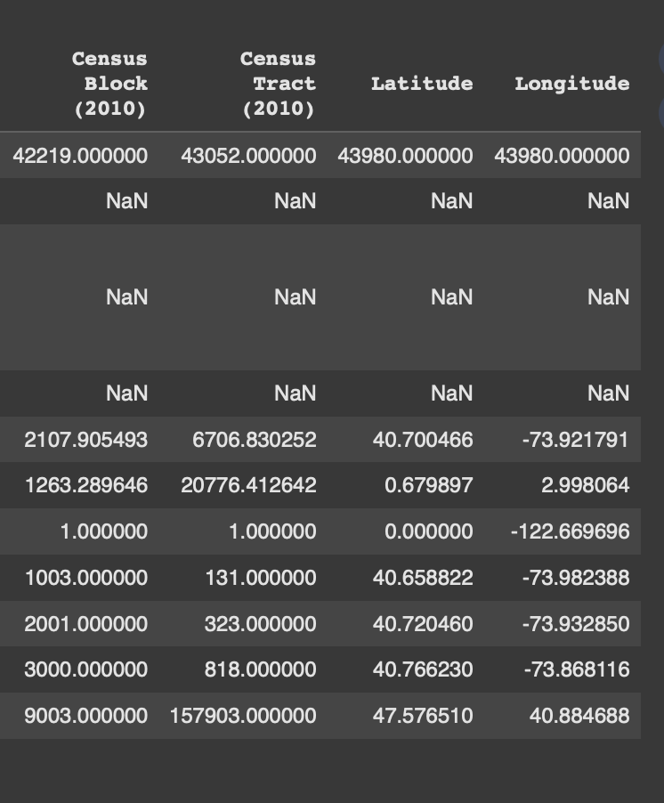

- Data types: Identify the types of data (numerical, categorical, text) and any conversion done between types as necessary.
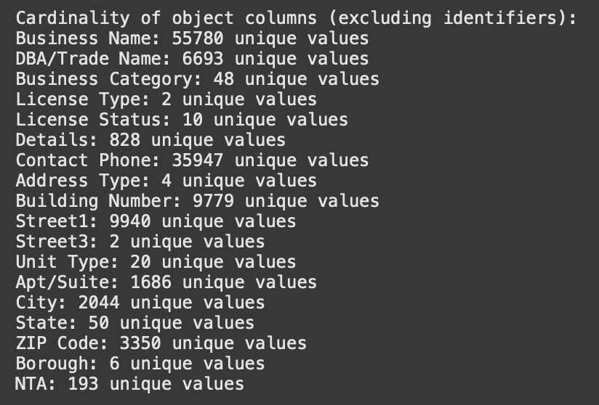

Potential columns for review/dropping (depending on future tasks):
- Low variance columns: ['Street2']
- Columns with >50% missing values: ['DBA/Trade Name', 'Details', 'Street2', 'Apt/Suite']
- Potentially redundant/less informative columns: ['DBA/Trade Name', 'Details', 'Contact Phone', 'Building Number', 'Street1', 'Street2', 'Street3_nan', 'Apt/Suite', 'City', 'ZIP Code', 'Community Board', 'Council District', 'BIN', 'BBL', 'NTA', 'Census Block (2010)', 'Census Tract (2010)', 'Latitude', 'Longitude']

- Categorical Columns: These columns have a limited number of unique values and represent categories.
- Business Category
- License Type
- License Status
- Address Type
- Street3
- Unit Type
- City
- State
- ZIP Code
- Borough
- NTA

- Numerical Columns: These columns contain numerical data.

- Street2 (Note: This column has all missing values)
- Community Board
- Council District
- BIN
- BBL
- Census Block (2010)
- Census Tract (2010)
- Latitude
- Longitude

- Text Columns: These columns contain free-form text.
- Business Name
- DBA/Trade Name
- Details
- Contact Phone
- Building Number
- Street1
- Apt/Suite

- Identifier Columns: These columns uniquely identify each record.
- License Number
- Business Unique ID
- Date Columns: These columns contain date and time information (already converted to datetime objects).
- Initial Issuance Date
- Expiration Date

Descriptive Statistics and Summarization:
- Central tendency and spread: What are the mean, median, mode, range, variance, and standard deviation of key numerical variables?
"Think of these columns like zip codes or phone numbers. They are made of numbers, but calculating the average zip code or the median phone number doesn't tell you anything useful about a location or a person. These numbers are really just ways to identify different places or categories.

For example:

Community Board, Council District, Census Block/Tract: These numbers point to specific neighborhoods or statistical areas on a map. Instead of talking about their average value, we'd look at how many licenses are in each district or which districts have the most licenses. We treat them like categories rather than measurements.
BIN (Building Identification Number) and BBL (Borough, Block, Lot): These are like unique addresses for buildings or land parcels. Averaging BINs wouldn't make sense. What's important is that each number points to a specific property.
Since these numbers are like codes and not measurements, the usual statistics like mean, median, variance, and standard deviation don't describe a typical 'value' or spread in the way they would for something like height or temperature. Instead, we'd analyze them by counting how often each code appears (like counting how many people live in each zip code) or by using them to group or map data."

Essentially, you're explaining that the numbers are nominal or ordinal data used for labeling or ordering, not interval or ratio data used for measurement, so different types of summaries (like counts and frequencies, or spatial analysis) are more appropriate.

